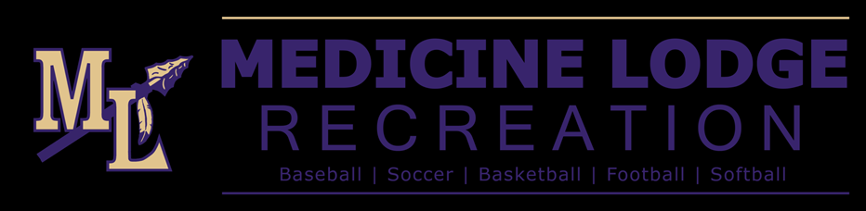

**North Barber County Recreation Commissions (NBCRC) Code of Ethics for Coaches**

I hereby pledge to live up to my certification as a NBCRC Coach by following the NBCRC Code of Ethics for Coaches:

* I will place the emotional and physical well being of my players ahead of a personal desire to win.
* I will treat each player as an individual, remembering the large range of emotional and physical development for the same age group.
* I will do my best to provide a safe playing situation for my players.
* I promise to review and practice basic first aid principles needed to treat injuries of my players.
* I will do my best to organize practices that are fun and challenging for all my players.
* I will lead by example in demonstrating fair play and sportsmanship to all my players.
* I will not cheat or engage in any form of unethical behavior that violates league rules.
* I will provide a sports environment for my team that is free of drugs, tobacco, and alcohol, and I will refrain from their use at all youth sports events.
* I will be knowledgeable in the rules, and I will teach these rules to my players.
* The coach shall not use abusive or profane language before anyone connected with any program activity.
* I will use those coaching techniques appropriate for all of the skills that I teach.
* I will remember that I am a youth sports coach, and that the game is for children and not adults.

**Coach Signature: ______________________________**

**Date: ________________**